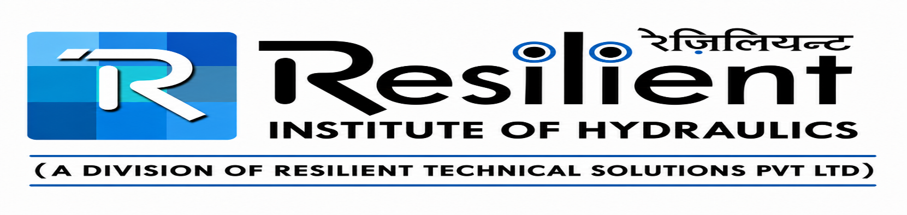
FOR ITI /DIPLOMA / POLYTECHNIC / B. TECH CANDIDATES HYDRAULIC TECHNICIAN COURSE DURATION WILL BE SIX MONTHS
Module 1 (90 Days)  - Hydraulics definition  - Comparison with other systems  - Basic parameters  - Fundamental Principles  - Building Blocks of Hydraulics Systems  - Hydraulic control components, their construction  - Assembly, disassembly and their role in the functioning of Hydraulics based equipment  - Oil contamination basics | Module 2 (90 Days)  - Complete Hydraulic system with the maintenance as the main focus  - Practical experience and revision for the participants before the final assessment and certification

FOR 10+2/ SCIENCE GRADUATES CANDIDATES HYDRAULIC TECHNICIAN COURSE DURATION WILL BE NINE MONTHS
Module 1 (90 days)
- Basic Mechanical Engineering includes industrial safety standards
- Drawing standards, tools, tackles, piping, welding, drilling, tapping etc. with shop-floor experience
- Hydraulics definition
- Comparison with other systems
- Basic parameters
- Fundamental Principles
- Building Blocks of Hydraulics Systems
Module 2 (90 Days)  - Hydraulic control components, their construction  - Assembly, disassembly and their role in the functioning of Hydraulics based equipment  - Oil contamination basics | Module 3 (90 Days)  - It brings together the complete Hydraulic system with the maintenance as the main focus  - practical experience and revision for the participants before the final assessment and certification.

